Name: __Kellie Hall______________ Date: __March 29, 2026___________

Fill in your name above, put your full response below the question, save the file using the file naming convention: “ISSC457_Lab3_LastName_FirstName.doc” where LastName is your last name and FirstName is your first name, then return this document for grading.
If you do not have the Hardware or Software, then review the lab only…

Hardware/Software Setup Required
Router or
CISCO Packet Tracer 5.0 (available at http://www.cisco.com/web/learning/netacad/index.html)
Note: The lab requires a CISCO router.

Problem Description
When investigating an attack to a router, you need to gather volatile evidence using either direct or indirect access. Direct access is carried out using show commands. Indirect access can be carried out only if the attacker has changed the passwords. This is done by port-scanning every router’s IP information.

In this lab, you will practice acquiring volatile information from a router using various show commands.

Estimated completion time: 60 minutes.

Outcome
Report the steps for performing the task above.

Validation/Evaluation
- How to use various show commands to display the following information:
  - Clock details
  - Router’s version
  - Running configuration
  - Startup configuration
  - Routing table
  - ARP table
  - List of users
  - List of interfaces
  - Routing protocols
Lab 3: Acquiring Volatile Information from a Cisco Router
To investigate a router-related attack, I connected to the router through the console interface
and used Cisco IOS show commands to collect volatile evidence without changing the system
configuration.
- I accessed the router through the console in Cisco Packet Tracer or directly on a Cisco
router and entered privileged EXEC mode using the enable command.
- I used the show clock to display the router’s current date and time, which helps establish

a timeline for the investigation. Type show clock and press Enter to display the router’s

clock.

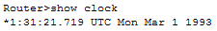

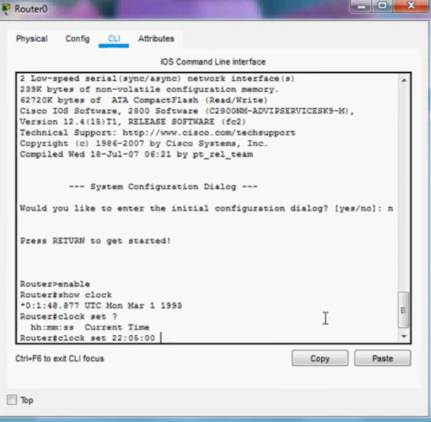

- I used show version to display the router’s IOS version, hardware information, uptime,
and boot details. To show the router’s version, type show version and press Enter.
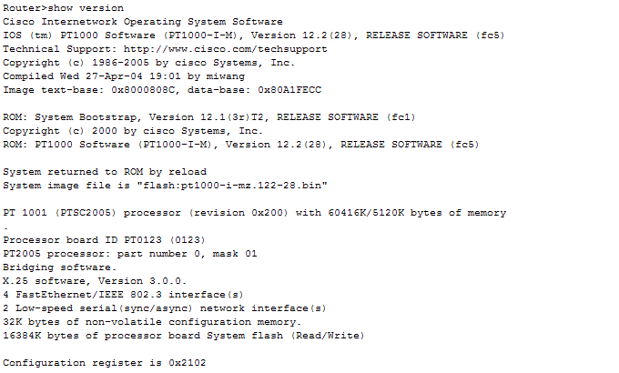

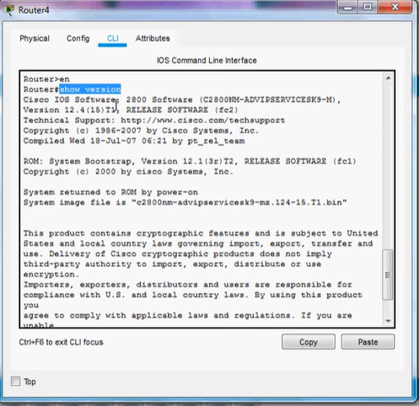

- I entered show running-config to view the active configuration currently stored in

memory. Type show running-config and press Enter to list the router’s running
configuration.

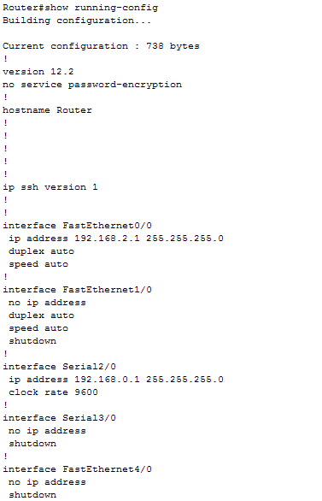

- I used show startup-config to view the configuration saved in NVRAM that loads when
the router restarts.
To recover the router’s startup configuration, type show startup-config and press Enter.

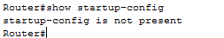
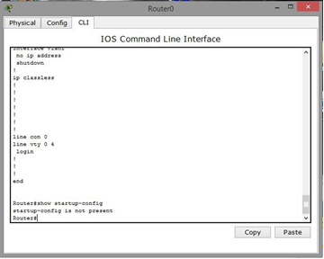

- I ran show ip route to display the router’s routing table and identify known routes and
path information.
Type show ip route and press Enter to display the router’s routing table.
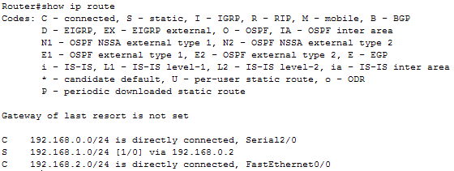

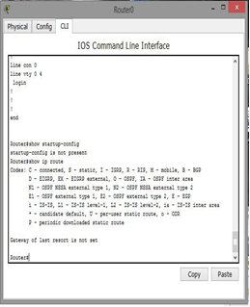

- I used show ip arp to view the ARP table and collect IP-to-MAC address mappings for
connected hosts.
If you want to display the router’s ARP table, type show ip arp and press Enter.
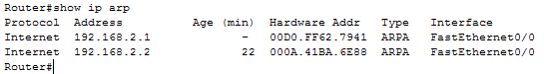

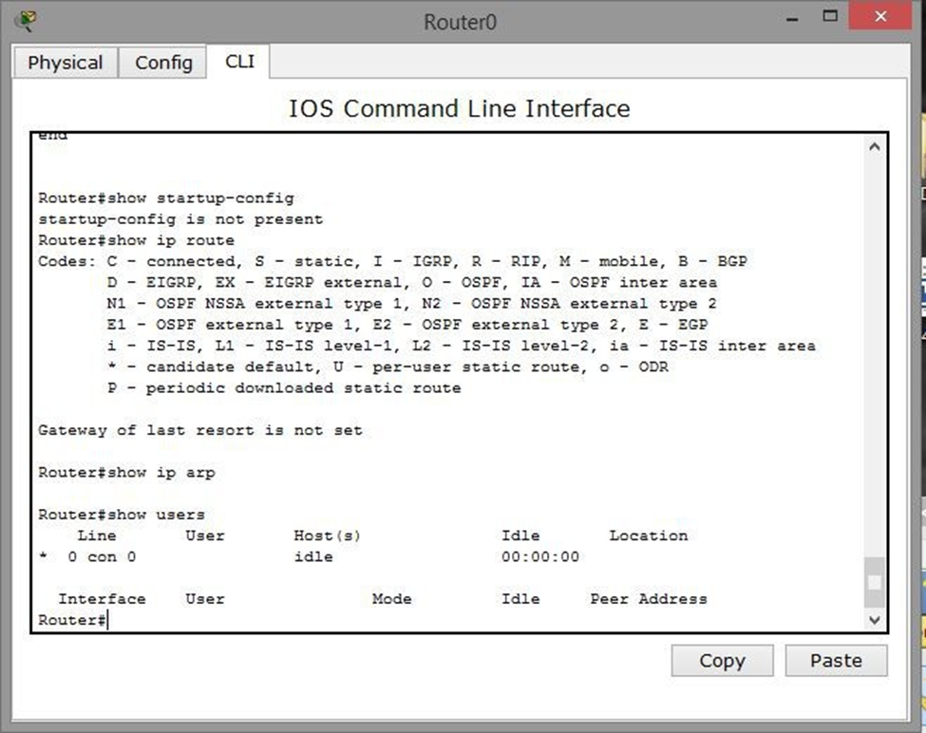

- I entered show users to list current users and active sessions on the router.
Type show users and press Enter to list all router’s users.

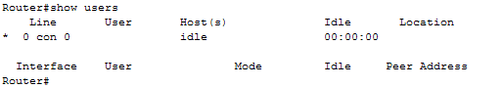
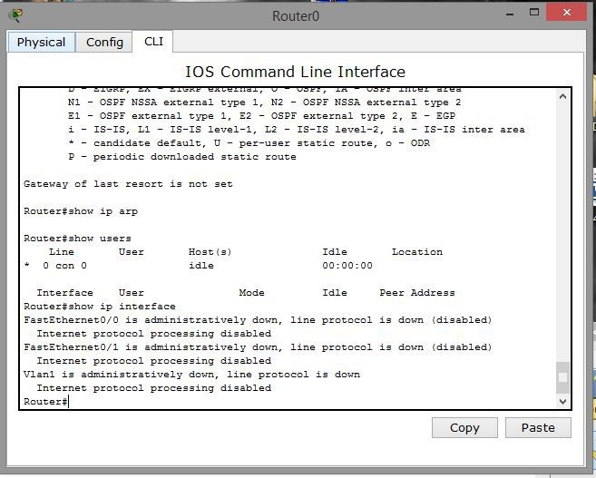
- I used show ip interface to display interface details such as IP addresses and interface
status.
The show ip interface command will display the list of router’s interfaces.
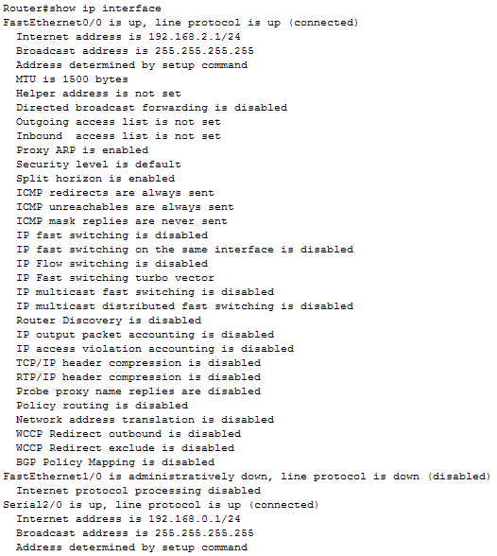

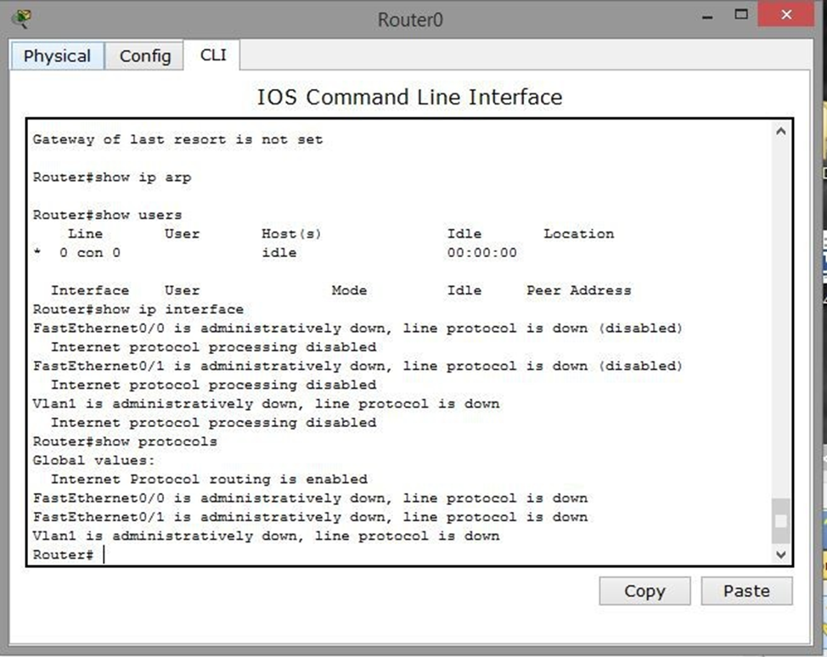
- I ran show protocols to identify the active routing protocols configured on the router.
Type show protocols to list the active network routing protocols.
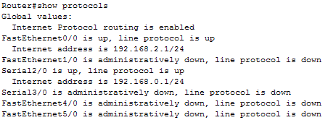

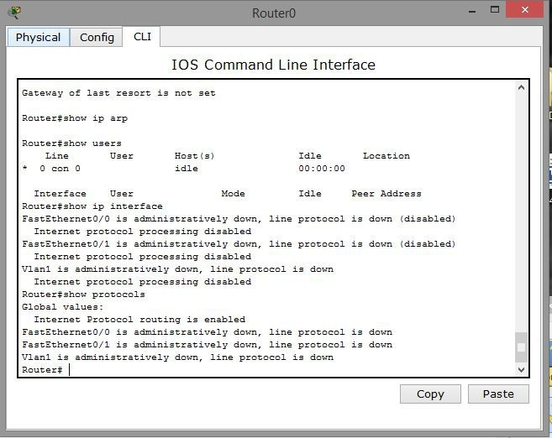

- Close all windows.

Summary

These commands allowed me to collect volatile evidence from the router,

including time, version, configuration, routing, ARP, user, interface, and protocol

information. This information is useful for incident response and forensic investigation

because it shows the router’s live operating state at the time of inspection.

References

Cisco Systems. (2024). Command Reference. Cisco.com. https://www.cisco.com/E-Learning/bulk/public/tac/cim/cib/using_cisco_ios_software/cmdrefs/show_ip_arp.htm

Cisco Systems. (2026a). Command Reference. Www.cisco.com. https://www.cisco.com/E-Learning/bulk/public/tac/cim/cib/using_cisco_ios_software/cmdrefs/show_startup-config.htm

Cisco Systems. (2026b). Command Reference. Www.cisco.com. https://www.cisco.com/E-Learning/bulk/public/tac/cim/cib/using_cisco_ios_software/cmdrefs/show_version.htm

Cisco Systems. (2026c). Command Reference. Cisco.com. https://www.cisco.com/E-Learning/bulk/public/tac/cim/cib/using_cisco_ios_software/cmdrefs/show_protocols.htm

Cisco Systems. (2026d). Command Reference. Cisco.com. https://www.cisco.com/E-Learning/bulk/public/tac/cim/cib/using_cisco_ios_software/cmdrefs/show_protocols.htm

Cisco Systems. (2026e). Command Reference. Cisco.com. https://www.cisco.com/E-Learning/bulk/public/tac/cim/cib/using_cisco_ios_software/cmdrefs/show_protocols.htm

Cisco Systems. (2026f). Command Reference. https://www.cisco.com/E-
Learning/bulk/public/tac/cim/cib/using_cisco_ios_software/cmdrefs/show_ip_route.htm

