Linux Log File Analysis

Kellie Hall
ISSC457
Digital Forensics:
Investigating Network Intrusions and Cybercrime Security
Dr. Arthur Salmon
March 15, 2026

Name: ____Kellie Hall_____________ Date: __March 15, 2026

Fill in your name above, put your full response below the question, save the file using the
file naming convention: “ISSC457_Lab1_LastName_FirstName.doc” where LastName is your
last name and FirstName is your first name, then return this document for grading.
In this lab: Review the steps only.

Estimated completion time: 60 minutes

Outcome

Report the steps you need to perform these tasks.

Validation/Evaluation

Apache, ProFTP, and Syslog are crucial tools for maintaining and managing Linux
systems, including Ubuntu. They each generate specific logs that can provide valuable
insights into system behavior, user activities, and potential issues. Here is where you can find
these logs and what they contain:
- Where can you find Apache logs?

On Ubuntu, you can find Apache logs in the /var/log/apache2/ directory (Negus &

Clinton, 2025)). This is the default location for Apache 2 log files, so investigators often start

here when checking web server activity (Easttom et al., 2024).

- What are some of the logs maintained by Apache?

Apache keeps several important log files. The main ones are access.log, which tracks all

HTTP requests, and error.log, which records server errors, configuration problems, runtime

issues, and module errors (Anjali Udasi, 2025). Depending on your Apache setup, it might

also create other_vhosts_access.log for virtual host activity and separate logs for each virtual

host (Anjali Udasi, 2025).

- Where can you find ProFTP logs?

On Ubuntu, ProFTP logs are usually stored in the /var/log/proftpd/ directory (Nawaz

Dhandala, 2026). This is the default location for ProFTPD, but you can change it in the

configuration file. Most standard setups use this path.

- What are some of the logs maintained by ProFTP?

ProFTPD maintains several logs that capture detailed FTP server activity.

- The primary log and proftpd.log record general server operations, including login

attempts, connection activity, and user authentication (Nawaz Dhandala, 2026).

- The xferlog file focuses on file transfers, documenting information like the username, file

path, transfer size, transfer direction, and completion status (Nawaz Dhandala, 2026).

- Administrators can customize or expand logging behavior by configuring the SystemLog,

TransferLog, and ExtendedLog directives in the ProFTPD configuration file.

- What are other common logs maintained in Ubuntu via Syslog?

The Location: These messages are typically stored in the /var/log/syslog file on Ubuntu systems.

Examples of these include the following:

Types of Systems Log:

- /var/log/syslog – General system messages and activity from various services and
daemons

- /var/log/auth.log – Authentication events, including successful and failed login attempts,
sudo commands, SSH sessions, and user authentication activities

- /var/log/kern.log – Kernel messages, hardware events, and low-level system information

- /var/log/daemon.log – Background service and daemon messages ​

- /var/log/messages – General system messages (on some distributions; Ubuntu primarily

uses syslog) ​

- /var/log/dpkg.log – Package installation, removal, and update events managed by the

Debian package manager ​

These logs are the foundation for forensic analysis. Enabling investigators to reconstruct

precise system timelines and pinpoint suspicious behavior, linking related data points across

disparate application events. Therefore, it provides the essential audit trail needed to track

evidence throughout incident response and digital investigations.

Lab Solution
- VMWare
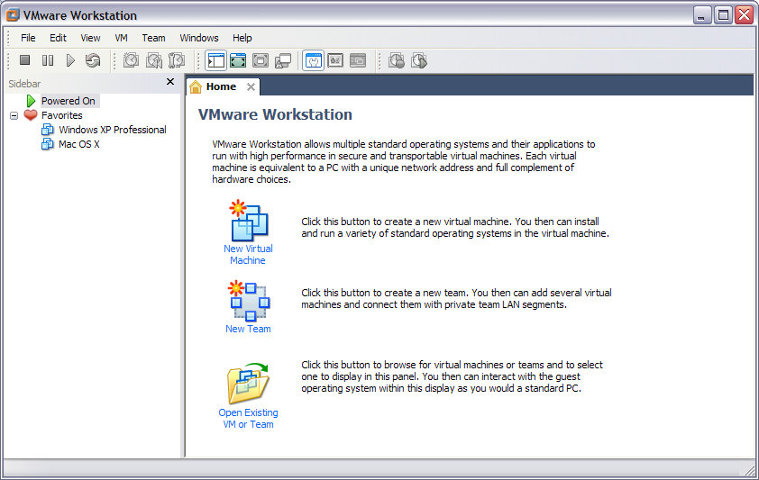
Note: We are using VMWare Workstation 6.5 for this exercise but the following steps are

similar for VMWare Player.

- Click on “Open Existing VM or Team” to open an existing virtual machine and browse to the

directory where you extracted the UbuntuWebServer image. Select the Ubuntu.vmx file and

click on Open.

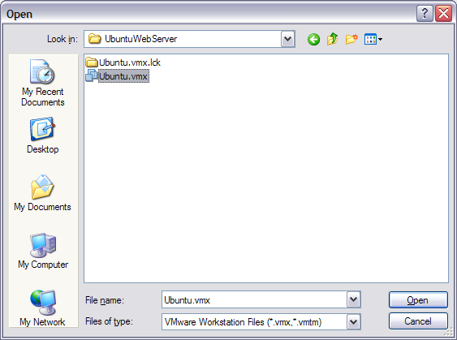
- Click on “Take Ownership” on the following dialog box.
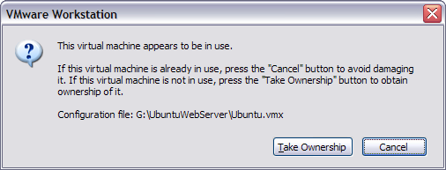

- Click on Power on this virtual machine to start the UbuntuWebServer virtual machine.
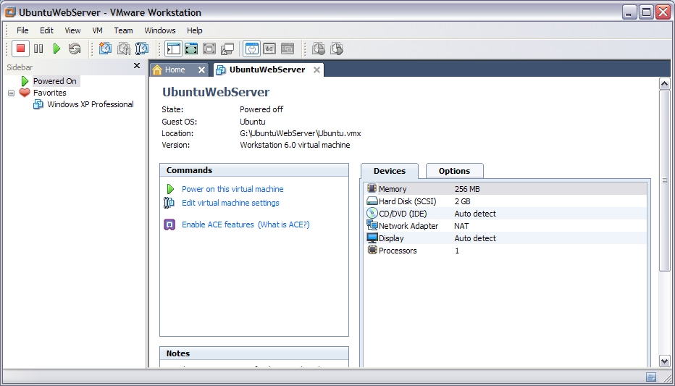
- On the next window, select “I copied it” and click OK.
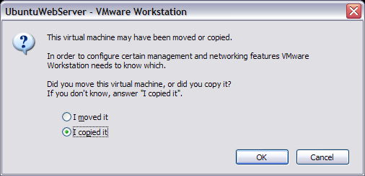
- Wait while the virtual machine starts.
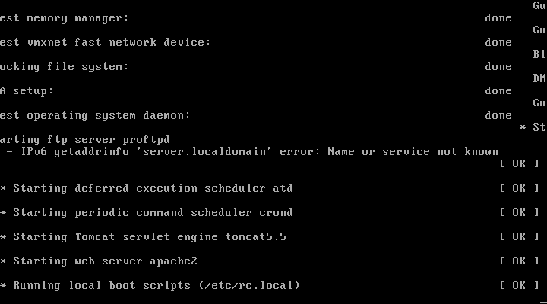
- Press Enter to bring up the login prompt and login with username root, and password

password.
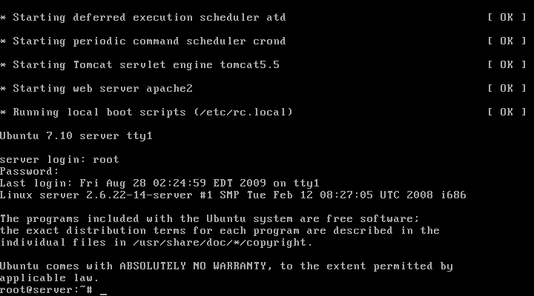
- Type cd /var/log and press Enter to go to the directory storing the log files.

- Type ls –la | more and press Enter to list all log files.

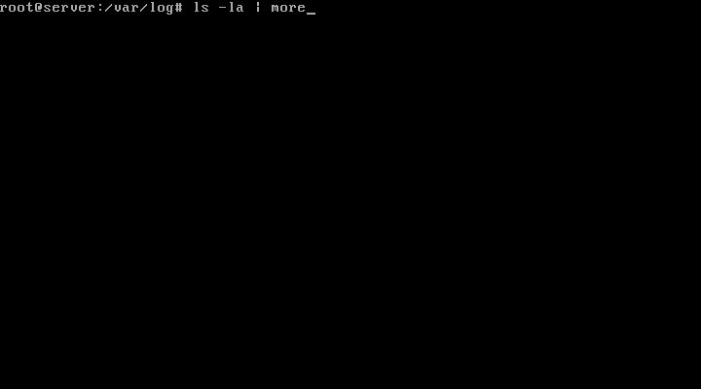
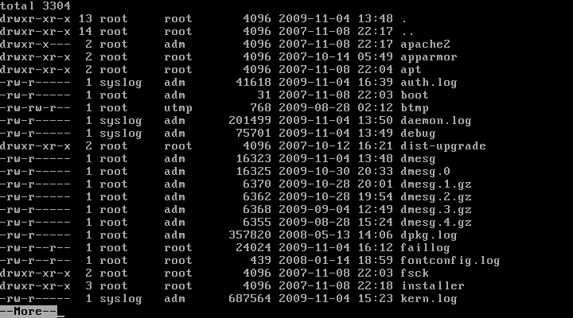

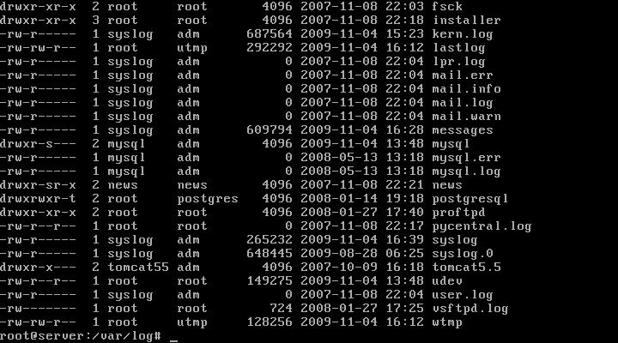

The most relevant log files include:
- auth.log
- daemon.log
- debug
- kern.log
- messages
- syslog

- Apache 2 stores its log files in /var/log/apache2. Type cd apache2 and press Enter to go to

this directory.

- Type ls –la and press Enter to list all log files used by Apache.
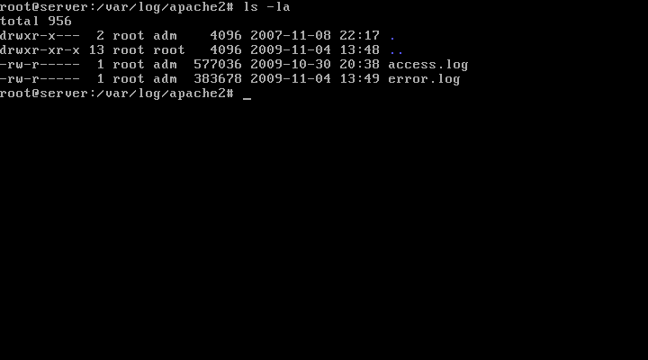

The access.log file keeps a record of all accesses to the Web server. The error.log file

stores error messages generated by the server.

- Type nano access.log and press Enter to open the access log file.
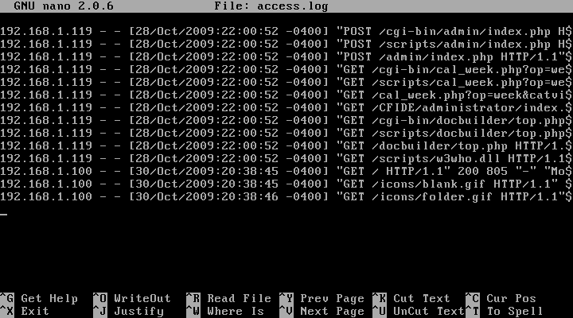
Get familiar with the structure of each entry in this log file.

- Next, type nano error.log and press Enter to open the error log file.
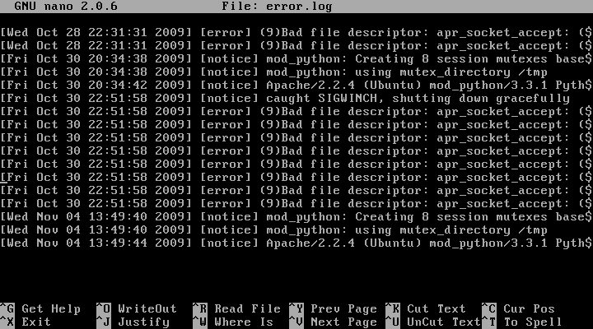
Again, get familiar with the structure of each entry in this log file.

- Now, go to the /var/log/proftpd/ directory on your UbuntuWebServer box. ProFTP is used by

Ubuntu Web Server to offer an FTP server. This tool logs all login attempts, both successful

and unsuccessful, to /var/log/proftpd/proftpd.log.
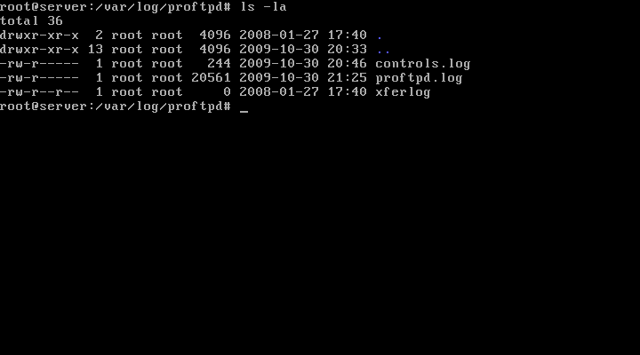
- Type nano proftpd.log and press Enter to open the access log file.
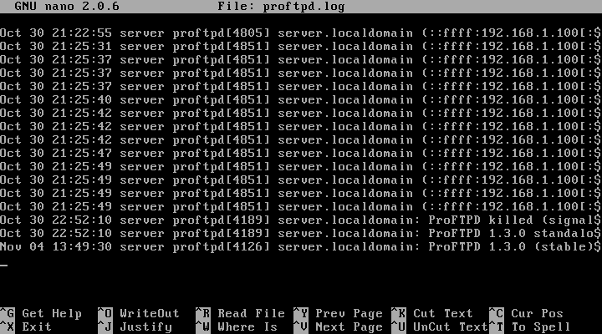
Get familiar with the structure of this log file.

- Close all windows.

References

Anjali Udasi. (2025, June 9). A Complete Guide to Linux Log File Locations and Their

Usage. Last9. https://last9.io/blog/linux-log-file-locations/

Nawaz Dhandala. (2026, March 2). How to Configure ProFTPD on Ubuntu Server.

OneUptime | One Complete Observability Platform.; OneUptime.

https://oneuptime.com/blog/post/2026-03-02-how-to-configure-proftpd-on-ubuntu-server/view

Negus, C., & Clinton, D. (2025). Ubuntu Linux Bible. Wiley.

