Name: __Kellie Hall_______ Date: _March 22, 2026____________

Fill in your name above, put your full response below the question, save the file using the file naming convention: “ISSC455_Lab2_LastName_FirstName.doc” where LastName is your last name and FirstName is your first name, then return this document for grading.
Lab 2 Details:
Hardware/Software Setup Required

OWASP ZAP(available here :https://www.zaproxy.org/

Problem Description

OWASP ZAP allows you to scan for Web sites vulnerabilities. An administrator can use

it to detect security problems on his or her own Web site and fix them before an attacker exploits

them.

In this lab, you will learn how to use OWASP ZAP to scan for Web site vulnerabilities.

Estimated completion time: 60 minutes.

Outcome
Report the steps for performing the task above.

I attempted to download Paros but was unsuccessful, although I was able to install

OWASP ZAP, which is the number one recommended replacement for Paros. The application

features an easy-to-use interface that enables users to quickly identify security vulnerabilities in

their websites (McCamon, 2019). The interface has an Automated Scan on in the top right

window. The field “URL to attack” is where you enter the desired site to attack and then click

the attack button with the lightning bolt on it. After the scan, the bottom left window will list the

vulnerabilities. You can click each alert to get more information about it. The window that pops

up will have a description of the alert, a solution for that problem, and also resources to reference

each problem. Like Paros, this site can help you identify issues with a website and then repair

them before a hacker can exploit the problem. You can save all your reports and choose to record

the entire session when the application starts up.

Validation/Evaluation

Add a website to OWASP ZAP
·
Scan for vulnerabilities to a cached website with OWASP ZAP
Lab Solution
- 1. Download and install OWASP ZAP.

OWASP ZAP can only scan for vulnerabilities on cached websites. The first
thing to do is to cache websites with ZAP. To cache a website, you need to open it with your preferred Web browser. Launched OWASP ZAP and chose to create a new session (File → New Session) to store scan data for the lab.

- Open your Web browser. Note: For this exercise, we will use Google Chrome as our
Web browser.
Scan a website for vulnerabilities.

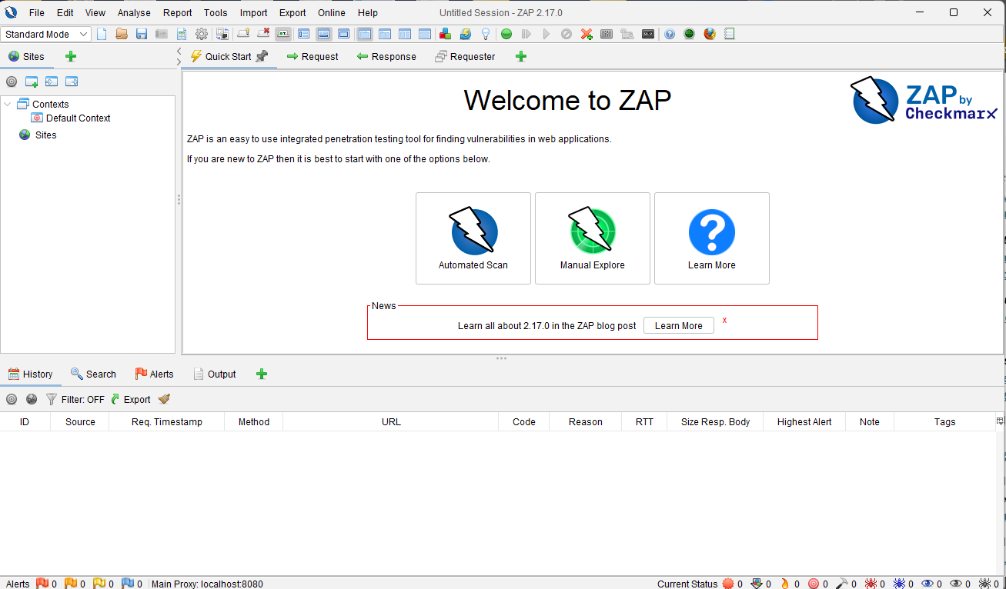

- ZAP can scan for vulnerabilities only for cached websites. To cache a Web site, you

need to open it with your preferred Web browser. Before that, you need to change the

proxy settings for your Web browser.

- Open your Web browser. Note: For this exercise, we will use Google Chrome as our

Web browser.
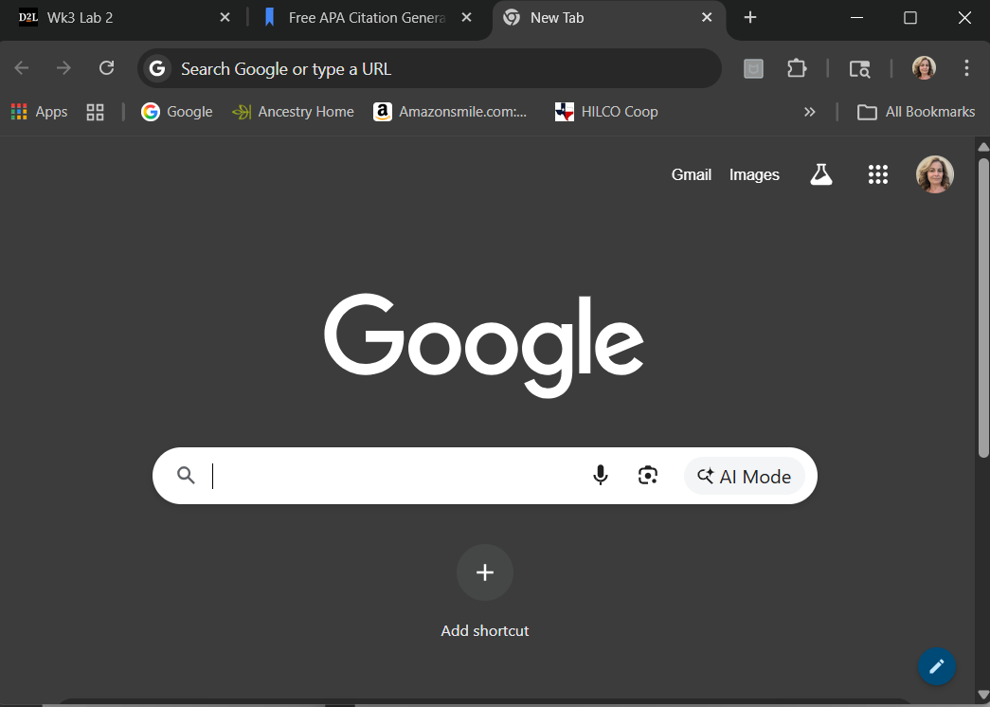

- Click on the “Customize and control Google Chrome” button and select Options to

change the proxy setting.

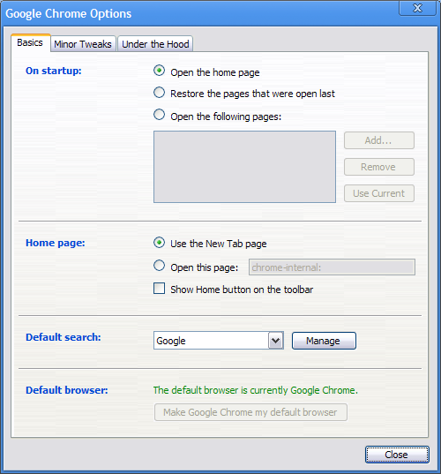

- Next, select the “Under the Hood” tab and scroll down to the Network section.
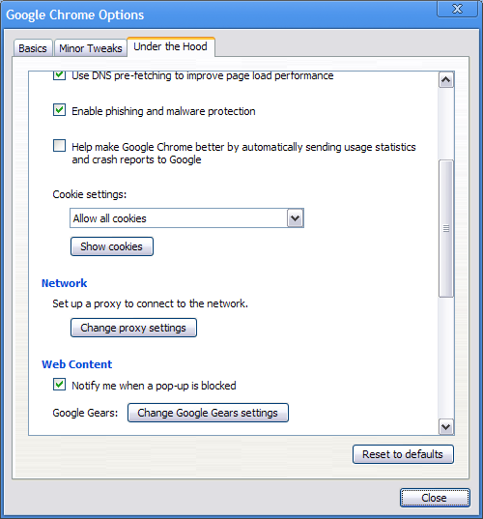

- Click on the “Change proxy settings” to open the Internet Properties window. On that

window, click on “LAN settings.”
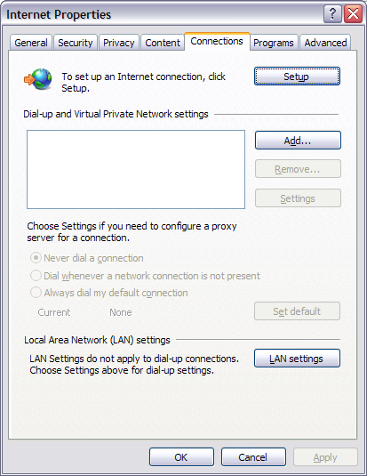

- Then, mark the option “Use a proxy server for your LAN.” Type localhost on the

Address field and 8080 on the Port field. Click OK.

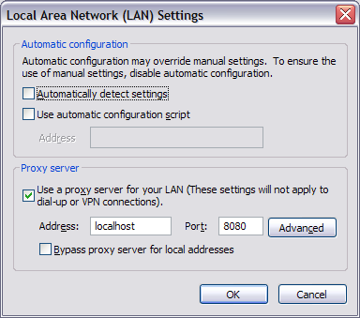
- Click OK again.

- Click Close to return to the Web browser.
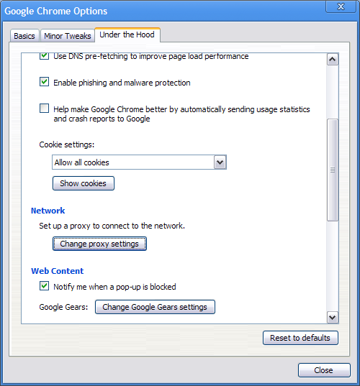

- Now, visit the Web site you want to scan as you would normally do it with your

browser. For example, if you want to scan your company’s Web site, type its

corresponding URL www.flickr.com in your Web browser to open it. ZAP will

automatically cache it. Note: Scanning should be done in safe environment.

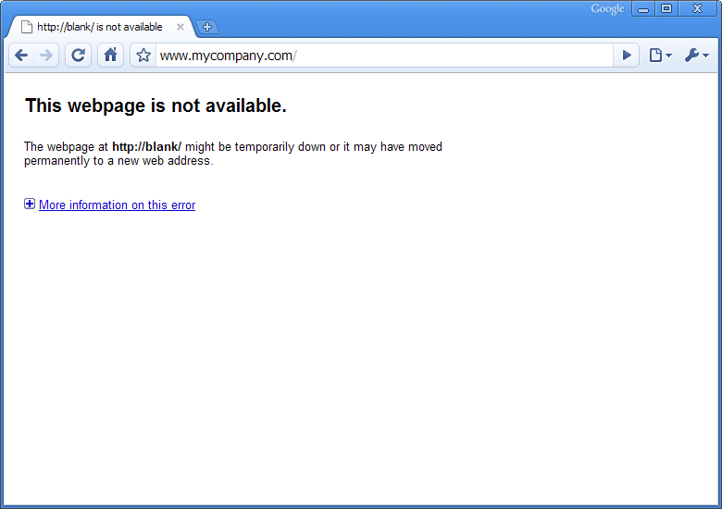

- Now, to start scanning the site for common vulnerabilities, select the site from the

Sites list on the left panel. Then, go to Analyse -> Scan. ZAP will automatically start

scanning your website.

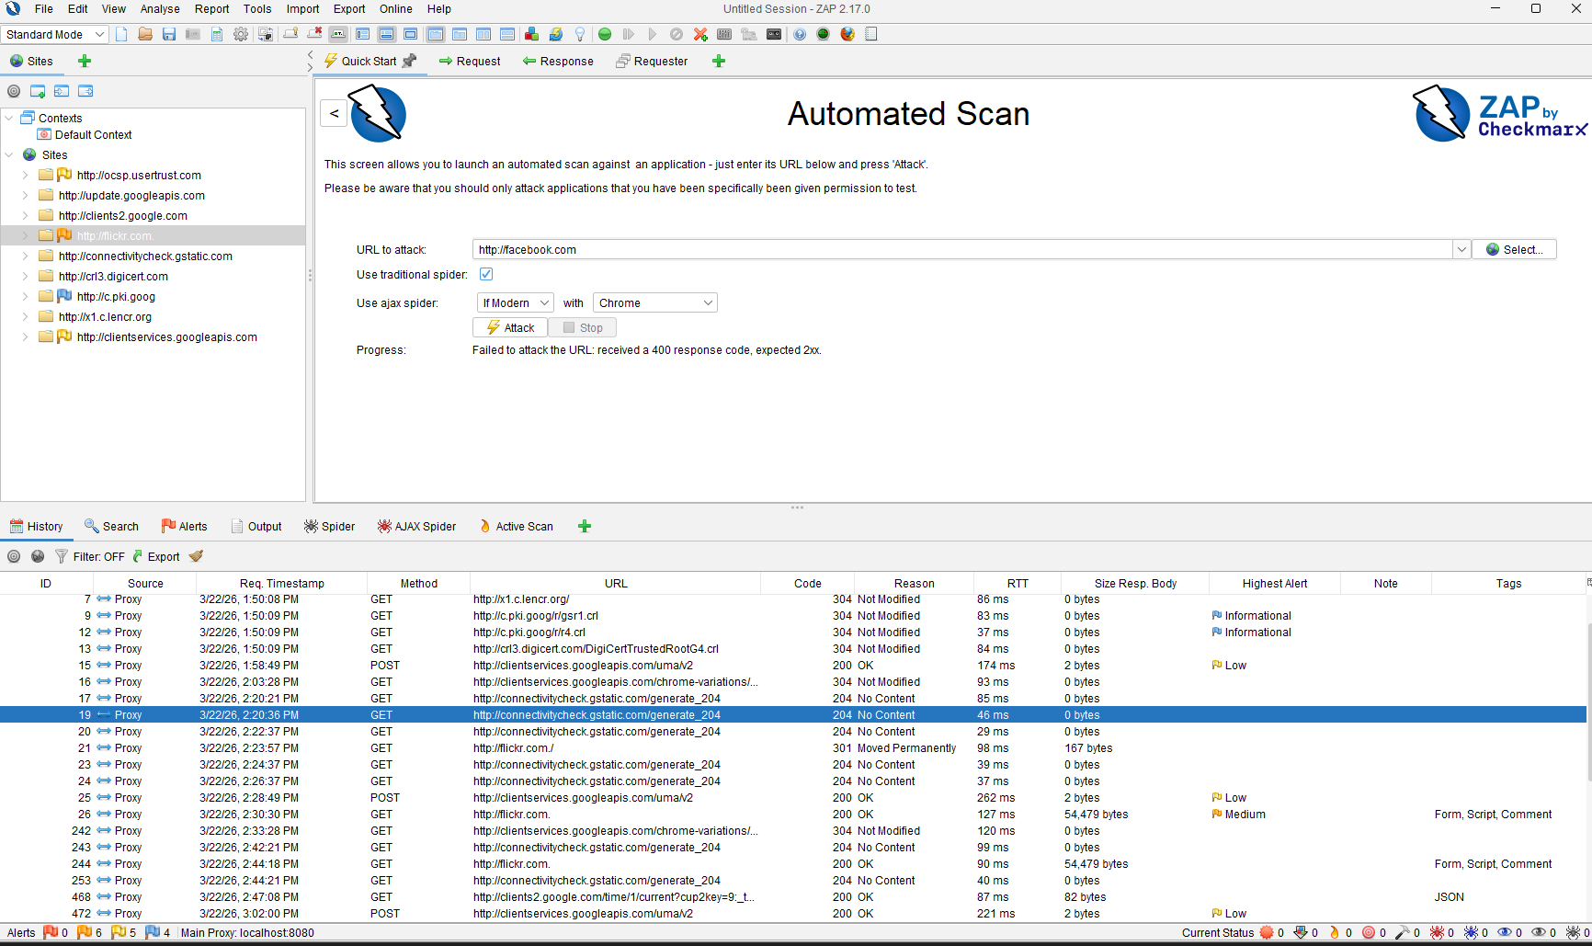

- Wait until ZAP finishes scanning your site.

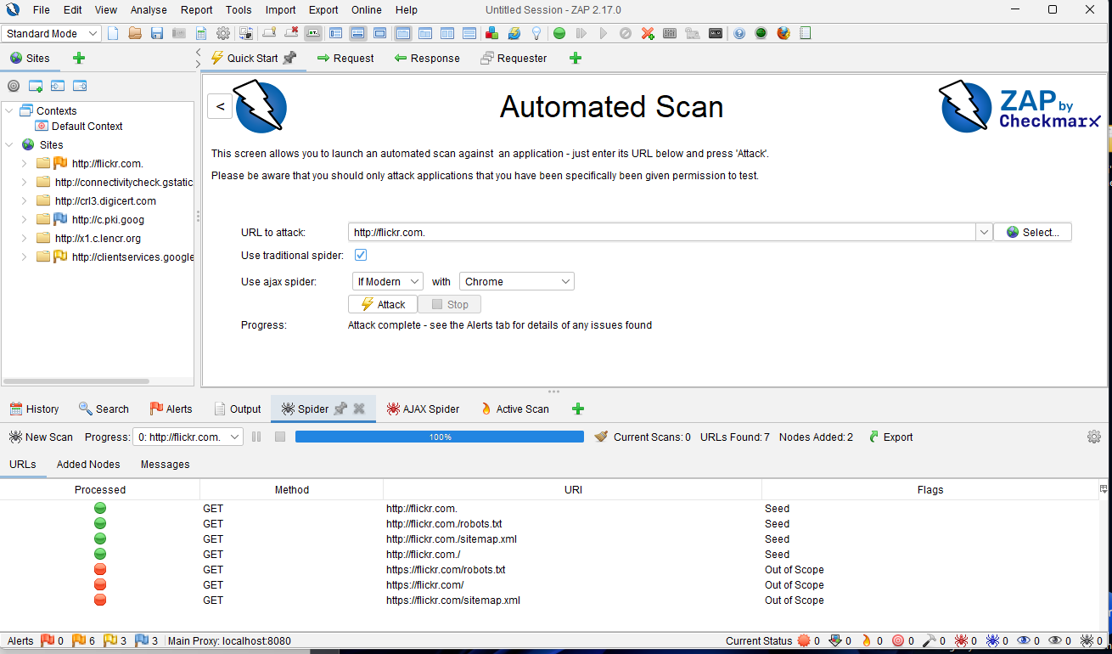

- Go to the Alerts tab on the bottom panel to view all the security problems ZAP found

for www.flickr.com.

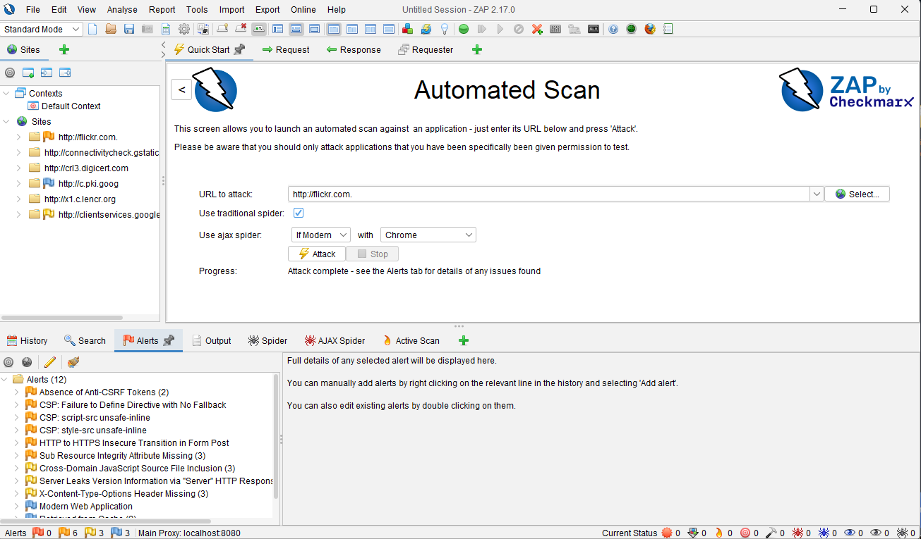

- At this point, you should try to fix all the issues listed and make your Web site

stronger.

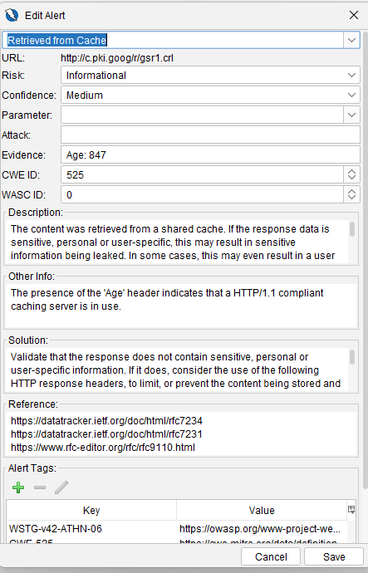

- Change back the proxy configuration on your Web browser.

- Close all windows.

References

OWASP ZAP – Alerts. (n.d.). Www.zaproxy.org. https://www.zaproxy.org/docs/desktop/start/features/alerts/

ZAP – Sites tab. (2026). Zaproxy.org. https://www.zaproxy.org/docs/desktop/ui/tabs/sites/

